

**WatchBot**

Surveying On-Site Construction Using Robot or Drone

by Ora Ora Group

Design Diagram

**Group Member**

Muhammad Haris Bin Harun

Muhammad Harith Bin Zainudin

Mohd Shakir Asyraf Bin Shazali

Iman Baharuddin

**Architecture Diagram**

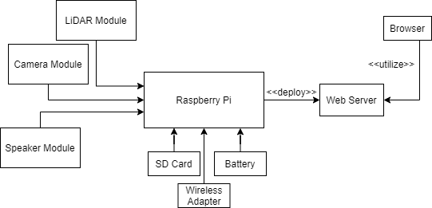

WatchBot will be using Raspberry Pi as it main circuit board and will be equipped with 5 main module in which is:-

● LiDAR Module - A Laser emitter to detect any obstacle or wall in front of the sensor. The way it works is basically it will throw a laser light at an object and then calculate the time taken to return to the LiDAR source. With a cheap LiDAR module, it can be used as an automatic collision handler for robots, but with high-end LiDAR modules, it can be used as a mapping machine for a terrain or building.

Our proposed technology for LiDAR module is TFMini LiDAR Module for collision detection or RPLIDAR 360 Laser Range for mapping

● Camera Module - Basically used for streaming and recording purposes. We suggest that the camera be at least equipped with shockproof and waterproof features to enable the bot to be active in rainy weather and survive any minimal impact.

Our proposed technology for camera module is Raspberry Pi Camera Module V2

● Speaker Module - To transmit messages. WatchBot will receive voice input data from its webpage which will be blasted through the WatchBot speaker. This can be used as an emergency call or if there is any change to the construction plan since it is not allowed to bring a cellphone in the construction area.

We have no proposed technology for speakers since most of them come with a cheap price, it is up to the stakeholder to pick the loudness of the speaker.

● Wireless Adapter - To enable wireless connection to the services produced by the Raspberry Pi module. Recommended either to use a strong wireless adapter or strong router to connect the robot to an access point which will then be accessed through the webpage.

We have no proposed technology for the wireless as most of them come at the same price, but if you asking us what kind of brand, we suggested using any TP-Link adapter as it is easy to setup and their router also comes at an affordable price

● SD Card - To install OS System and act as a storage for development process. In order to develop web services, we need to use a certain programming language which will need an OS to operate on. We targeting on using Python and web programming language for this project, so an OS is needed to be installed into the raspberry pi

As for OS, we proposed using OSMC as it is a universal OS with a bigger community online. Beside that, it is a universal OS for raspberry pi which is not tied to a specific purpose of the raspberry pi such as pure streaming, pure driving, etc. For SD Card we suggest using a high speed read data as we want the data to be streamed as real time as possible.

As for the other component which is battery, it is up to what module will be used and will be calculated after the decision has been made.

Regarding the development phase, there are plenty of guides in which we can follow online and most of them are Python and Linux based which is not that hard to learn even for a beginner developer. The only problem will be in integrating various module data into web services which we believe can be easily tackled.

**Use Case Diagram**

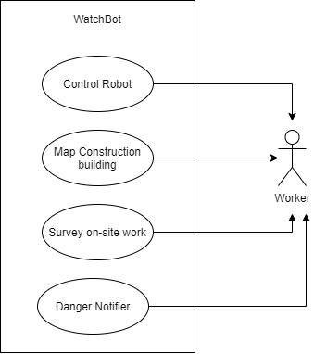

Control Robot - Ability to control robot movement and all of the sensor

Map Construction Building - Ability to generate 2D/3D map of the building/room using LiDAR sensor

Survey on-site work - Ability to view on-site situation realtime through video streaming

Danger Notifier - Ability to alert the surrounding for things such as emergency, spotted bad safety precaution and for information relay to the site.

**Class Diagram**

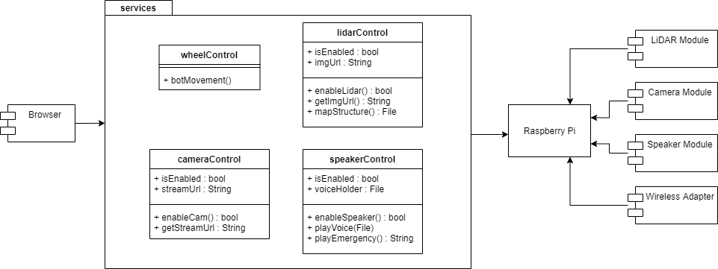

Basically we will create a web application which integrates Raspberry Pi components through a web server. Raspberry Pi will be equipped with a few modules which are LiDAR (a light emitting sensor module), Camera (streaming video), Speaker, Wireless Adapter (to connect through wireless) and an SD Card (deploy development OS and in-out data). Raspberry Pi will deploy the developed service through an existing web server such as AWS or Heroku apps and then we will use the services in the webpage which will be accessed by the user.

Most of the method and class name are self-explained, but there are certain methods which need to be clarified.

getStreamUrl() - Get the URL which camera is stream is published

mapStructure() - Map a 2D map of the current room or floor. Will return an Image file with File variable

playEmergency() - Will play predefined sounds such as alarm or help call to alert people on the site. Will return String after each voice played

**Sequence Diagram**



